# % Expt. No.2

**% Aim: Perform the following basic operations on image:**

# % a. Obtain Negative image

**% b. Obtain Flip image**

clc; clear all; close all;

I = imread('cameraman.tif'); I1 = 255-I;

subplot(1,2,1), imshow(I), title('Original Image'); subplot(1,2,2), imshow(I1), title('Negative Image');

# Output:

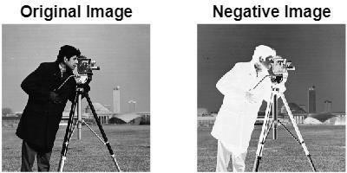

**% Expt. No. 2**

# % Aim: Perform the following basic operations on image:

**% b. Obtain Flip image**

clc; clear all; close all;

org_img = imread('cameraman.tif'); M = size(org_img,1);

N = size(org_img,2); for i = 1:M

for j = 1:N

n_img(i,j) = org_img(i,N-j+1) subplot(4,3,2), imshow( n_img(i,j)); end

end

# Output:

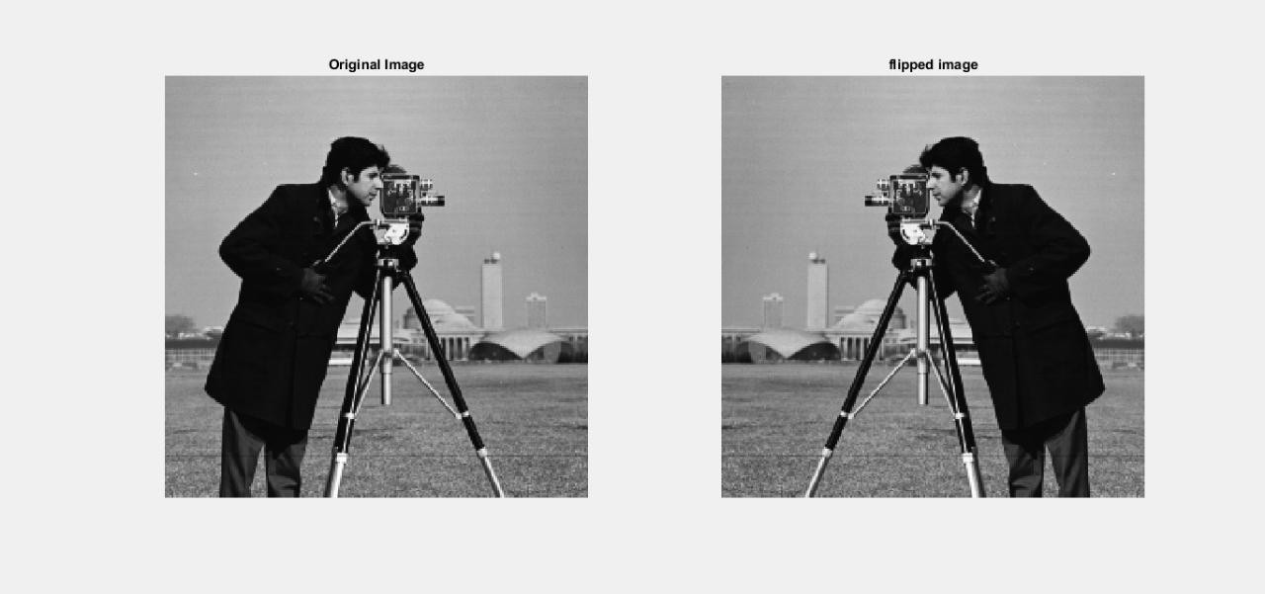

**% Expt. No. 3**

# % Aim: Read an image and to extract 8 different planes i.e 'bit plane slicing'

clc; clear all;

close all;

f = imread('cameraman.tif'); b7 = (zeros(256));

b6 = (zeros(256));

b5 = (zeros(256));

b4 = (zeros(256));

b3 = (zeros(256));

b2 = (zeros(256));

b1 = (zeros(256));

b0 = (zeros(256));

for i = 1:256 for j = 1:256

y = fliplr(dec2bin(f(i,j),8));

b0(i,j) = bin2dec(y(1));

b1(i,j) = bin2dec(y(2));

b2(i,j) = bin2dec(y(3));

b3(i,j) = bin2dec(y(4));

b4(i,j) = bin2dec(y(5));

b5(i,j) = bin2dec(y(6));

b6(i,j) = bin2dec(y(7));

b7(i,j) = bin2dec(y(8));

end end

subplot(3,3,1); imshow(f); title('Orignal Image'); subplot(3,3,2); imshow(b7); title('7th Plane'); subplot(3,3,3); imshow(b6); title('6th Plane'); subplot(3,3,4); imshow(b5); title('5th Plane'); subplot(3,3,5); imshow(b4); title('4th Plane'); subplot(3,3,6); imshow(b3); title('3rd Plane'); subplot(3,3,7); imshow(b2); title('2nd Plane'); subplot(3,3,8); imshow(b1); title('1st Plane'); subplot(3,3,9); imshow(b0); title('0th Plane');

# Output:

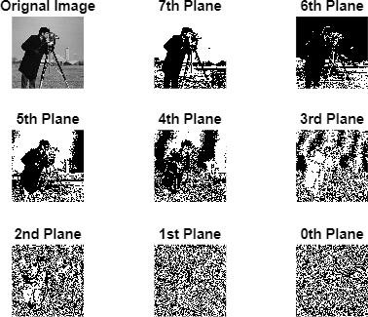

**% Expt. No.3**

# % Grey level slicing with background

clc; clear all; close all;

p = imread('cameraman.tif'); z = p;

[m,n] = size(p); for i = 1:m

for j = 1:n if((z(i,j))>50)&&(z(i,j)<150) z(i,j) = 255;

else

z(i,j) = p(i,j); %condition for grey level slicing with background end

end end

figure(1);

imshow(p), title('Orignal Image') figure(2);

imshow(z), title('Grey Level Slicing With Background');

# % Output:

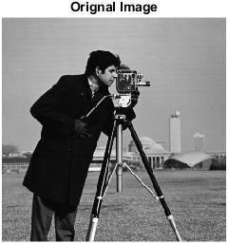

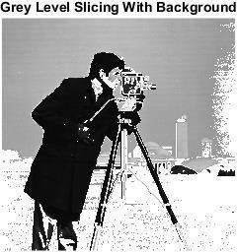

**% Expt. No.3**

# % Grey level slicing without background

clc; clear all; close all;

p = imread('cameraman.tif');

z = p;

[m,n] = size(p); for i = 1:m

for j = 1:n if((z(i,j))>50)&&(z(i,j)<150) z(i,j) = 0;

else

z(i,j) = p(i,j); % Condition for grey level slicing with background end

end end

figure(1);

imshow(p), title('Orignal Image') figure(2);

imshow(z), title('Grey Level Slicing Without Background')

# Output:

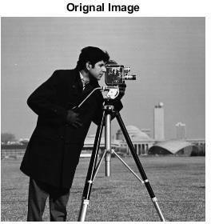

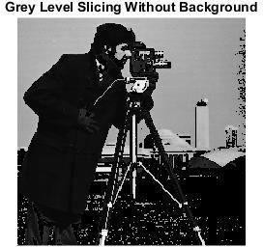

**% Expt. No.: 4**

# % Aim/Title: Write a program to implement image filtering in spatial domain (Using Readymade)

clc; clear all; close all;

J = imread('cameraman.tif'); I = imnoise(J,'gaussian');

I = double(I);

**% Readymade function** m1 = fspecial('average',2); m2 = fspecial('average',3);

m3 = fspecial('laplacian',0.2); m4 = fspecial('laplacian',0.6); m5 = fspecial('gaussian',3); m6 = fspecial('gaussian',2);

# % Convolution of filters

o4 = conv2(I,m1,'same');

o5 = conv2(I,m2,'same');

o6 = conv2(I,m3,'same');

o7 = conv2(I,m4,'same');

o8 = conv2(I,m5,'same');

o9 = conv2(I,m6,'same');

figure

subplot(331), imshow(J), title('original image');

subplot(332), imshow(uint8(I)), title('Noise added image image'); subplot(333), imshow(o4,[]), title('Avg Filter');

subplot(334), imshow(o5,[]), title('Avg filter'); subplot(335), imshow(o6,[]), title('laplacian filter');

subplot(336), imshow(o7,[]), title('laplacian filter'); subplot(337), imshow(o8,[]), title('gaussian filter'); subplot(338), imshow(o9,[]), title('gaussian filter');

# Output:

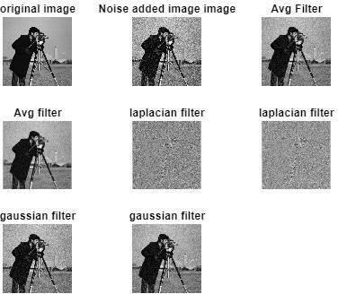

**% Expt. No.: 4**

# % Aim/Title: Write a program to implement image filtering in spatial domain (Using User defined)

clc; clear all; close all;

a = imread('cameraman.tif'); b = imnoise(a,'salt & pepper'); b = double(b);

c = imnoise(a,'gaussian'); c = double(c);

d = imnoise(a,'speckle'); d = double(d);

h1 = 1/9*ones(3,3); % 3*3 average h2 = 1/25*ones(5,5); % 5*5 average

h3 = (1/16).*[1,2, 1; 2, 4, 2; 1, 2, 1]; %weighted average h4 = (1/9).*[-1,-1,-1;-1,8,-1;-1,-1,-1]; %laplacian filter

b1 = conv2(b,h1,'same');

b2 = conv2(b,h2,'same');

b3 = conv2(b,h3,'same');

b4 = conv2(b,h4,'same');

c1 = conv2(c,h1,'same');

c2 = conv2(c,h2,'same');

c3 = conv2(c,h3,'same');

c4 = conv2(c,h4,'same');

d1 = conv2(d,h1,'same');

d2 = conv2(d,h2,'same');

d3 = conv2(d,h3,'same');

d4 = conv2(d,h4,'same');

# % Salt and pepper figure;

subplot(231), imshow(a), title('original image');

subplot(232), imshow(uint8(b)), title('salt and pepper image'); subplot(233), imshow(uint8(b1)), title('2*2 average filter'); subplot(234), imshow(uint8(b2)), title('5*5 average filter'); subplot(235), imshow(uint8(b3)), title('weighted average'); subplot(236), imshow(uint8(b4)), title('laplacian filter');

# % Gaussian

figure;

subplot(231), imshow(a), title('original image'); subplot(232), imshow(uint8(c)), title('gaussian'); subplot(233), imshow(uint8(c1)), title('2*2 average filter'); subplot(234), imshow(uint8(c2)), title('5*5 average filter'); subplot(235), imshow(uint8(c3)), title('weighted average'); subplot(236), imshow(uint8(c4)), title('laplacian filter');

# % Speckle

figure;

subplot(231), imshow(a), title('original image'); subplot(232), imshow(uint8(d)), title('speckle'); subplot(233), imshow(uint8(d1)), title('2*2 average filter'); subplot(234), imshow(uint8(d2)), title('5*5 average filter'); subplot(235), imshow(uint8(d3)), title('weighted average'); subplot(236), imshow(uint8(d4)), title('laplacian filter');

**Output:**

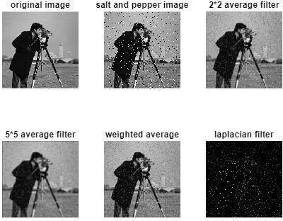

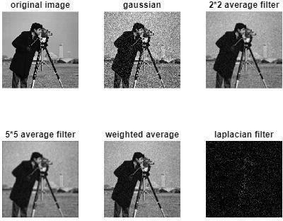

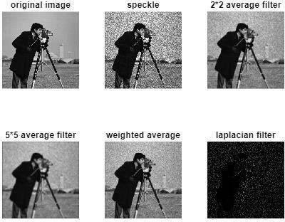

**% TE Expt No.5**

**% Aim: Perform the following basic operations on image:-**

**% a. Point Detection, b. Line Detection, c. Edge Detection, d. Thresholding**

**clc; clear all; close all;**

**% a. Point Detection**

**% I=imread('cameraman.tif'); I=imread('circuit.tif');**

**I = double(I);**

**I11 = [-1 -1 -1; -1 8 -1; -1 -1 -1]; I22 = conv2(I, I11);**

**subplot(2,3,1); imshow(uint8(I));title('Orignal Image'); subplot (2,3,2); imshow(I22), title('Using Point Detection');**

**% b. Line Detection**

**I1 = [-1 -1 -1;2 2 2; -1 -1 -1];**

**I2 = [-1 -1 2;-1 2 -1; 2 -1 -1];**

**I3 = [-1 2 -1;-1 2 -1; -1 2 -1];**

**I4 = [2 -1 -1;-1 2 -1; -1 -1 2]; I5 = conv2(I, I1);**

**I6 = conv2(I, I2); I7 = conv2(I, I3); I8 = conv2(I, I4);**

**subplot (2,3,3); imshow(I5), title('Horizontal Line Detection'); subplot (2,3,4); imshow(I6), title('+45 degree Line Detection'); subplot (2,3,5); imshow(I7), title('Vertical Line Detection'); subplot (2,3,6); imshow(I8), title('-45 degree Line Detection');**

**Output:-**

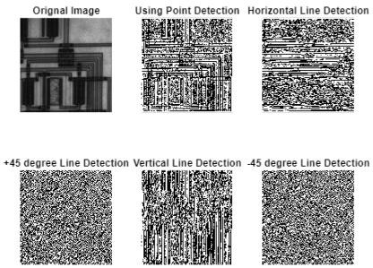

**% TE Expt No.5**

**% Aim:Perform the following operations on image :**

**% a)Point detection % b)Line detection**

**% c)Age detection % D)Thresholding**

**%D)Thresholding clc;**

**clear all; close all;**

**a=imread('cameraman.tif'); [m n]=size(a);**

**t=input('Enter the Threshold parameter:'); for i=1:m**

**for j=1:n**

**if a(i,j)<t b(i,j)=0;**

**else**

**b(i,j)=255;**

**end end**

**end**

**subplot(1,2,1),imshow(a),title('Original Image'); subplot(1,2,2),imshow(b),title('Threshold Image'); xlabel(sprintf('Threshold value is %g',t));**

**% OUTPUT**

**% Enter the Threshold parameter:45**

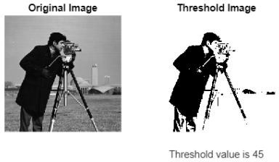

# % Expt. No. 6

**% Title/Aim: Implement and study the effect of Different Mask (Sobel, Prewitt and Roberts) (Readymade Function)**

clc; clear all; close all;

# % Using Readymade inbuilt function

a = imread('circuit.tif'); b = edge(a, 'roberts');

c = edge(a, 'Sobel'); d = edge(a, 'Prewitt'); e = edge(a, 'log');

f = edge(a, 'canny');

subplot(3,2,1); imshow(a), title('Original Image');

subplot(3,2,2); imshow(b), title('Roberts');

subplot(3,2,3); imshow(c), title('Sobel');

subplot(3,2,4); imshow(d), title('Prewitt');

subplot(3,2,5); imshow(e), title('Log');

subplot(3,2,6); imshow(f), title('Canny');

# Output:

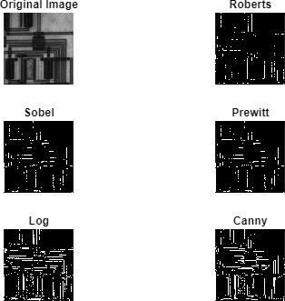

**% Expt. No. 6**

# % Aim: Implement and study the effect of Different Mask (Sobel, Prewitt and Roberts)

clc; clear all; close all;

# % Using userdefined function

% Mask for Roberts

a1 = imread('circuit.tif');

a1 = im2double(a1); h5 = [1 0;0 -1];

M = conv2(a1,h5,'same');

h6 = [0 1;-1 0];

N = conv2(a1,h6,'same');

O = imadd(M,N); figure;

subplot(221), imshow(a1), title('Original Image');

subplot(222), imshow(uint8(M)); subplot(223), imshow(uint8(N));

subplot(224), imshow(uint8(O)), title('Roberts Mask');

% Mask for Prewitt

h1 = [1 1 1;0 0 0; -1 -1 -1];

g = conv2(a1,h1,'same');

h2 = [-1 0 1;-1 0 1;-1 0 1];

h = conv2(a1,h2,'same'); I = imadd(g,h);

figure;

subplot(221), imshow(a1), title('Original Image');

subplot(222), imshow(uint8(g)), title('Horizontal Lines'); subplot(223),

imshow(uint8(h)), title('Vertical Lines'); subplot(224), imshow(uint8(I)), title('Prewitt Mask');

% Mask for Sobel

h3 = [-1 0 1;-2 0 2;-1 0 1];

J = conv2(a1,h3,'same');

h4 = [1 2 1;0 0 0;-1 -2 -1];

K = conv2(a1,h4,'same');

L = imadd(J,K); figure;

subplot(221), imshow(a1), title('Original Image'); subplot(222), imshow(uint8(J)), title('Vertical Lines');

subplot(223), imshow(uint8(K)), title('Horizontal Lines'); subplot(224), imshow(uint8(L)), title('Sobel Mask');

# Output:

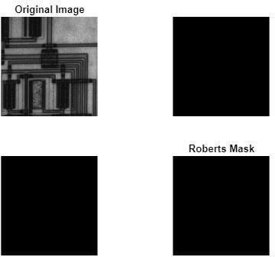

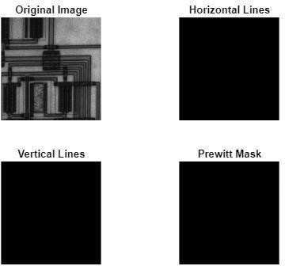

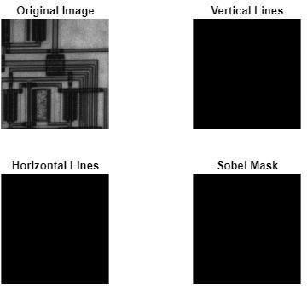

**% Expt. No.7**

# % Implement various noise models and their histogram

clc;

clear all; close all;

a = 0;

b = 1;

f = imread('cameraman.tif'); f1 = double(f);

[r,c] = size(f);

I = input('What noise do you want to add? Uniform = 1; Rayleigh = 2; Expo = 3:');

if I == 1

R = a+(b-a)*rand(r,c); %Uniform elseif I == 2

R = a+(-b*log(1-rand(r,c))).^0.5;%Rayleigh elseif I == 3

R = -log(1-rand(r,c)); %Exponential

end

mmax = max(max(R)); mmin = min(min(R));

const = 100/(mmax-mmin); for x = 1:1:r

for y = 1:1:c

noise(x,y) = const*(R(x,y)- mmin); end

end

noisy_image = f1 + noise;

figure(1), imshow(f); figure(2), hist(noise);

figure(3), imshow(uint8(noisy_image));

# %Output:

**% 1. Which noise do you want to add? Uniform = 1; Rayleigh = 2; Expo = 3: 1**

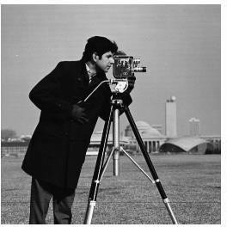

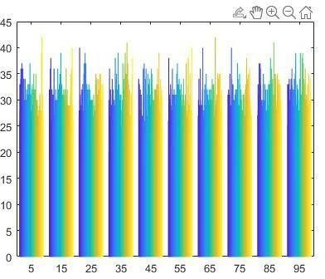

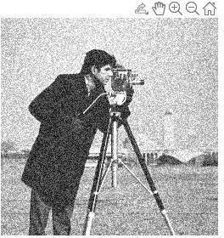

# % 2. Which noise do you want to add? Uniform = 1; Rayleigh = 2; Expo = 3: 2



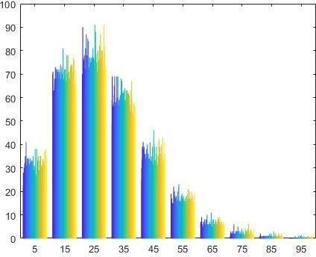

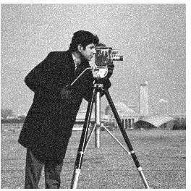

**% 3 Which noise do you want to add? Uniform = 1; Rayleigh = 2; Expo = 3: 3**



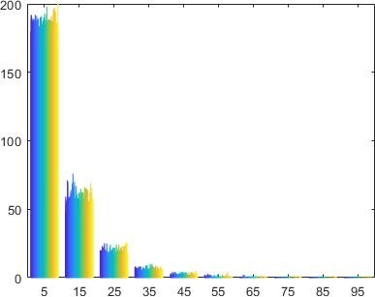

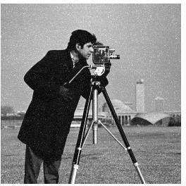

# % Expt. No. 8

**% Aim :-Histogram Equalisation (using readymade function)**

clc; close all; clear all;

a = imread('cameraman.tif');

# % Histogram equalization using readymade function

b = histeq(a);

subplot(2,2,1), imshow(a), title('original img'); subplot(2,2,2), imshow(b), title('after hist equalization'); subplot(2,2,3), imhist(a), title('original hist'); subplot(2,2,4), imhist(b), title('after hist equalisation');

# Output:

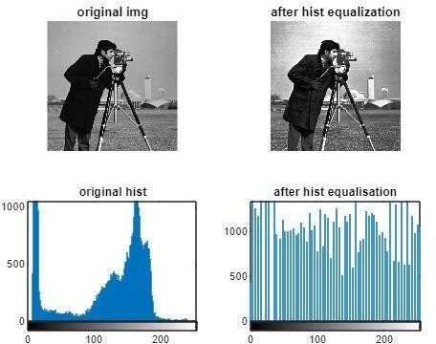

**% Expt. No. 8**

# % Aim/ Title: Read an image, plot its histogram then do histogram equalization. Comment about the result. (Using User defined)

clc;

close all; clear all;

a = imread('cameraman.tif'); figure;

subplot(2,1,1); imshow(a); title('Original Image'); subplot(2,1,2); imhist(a); title('Histogram');

# % Using readymade function

[mr,mc] = size(a);

**% Declaration of all variables** him = uint8(zeros(mr,mc)); freq = zeros(256,1);

prob = zeros(256,1); pdf = zeros(256,1); cu = zeros(256,1); op = zeros(256,1); nopixels = mr*mc; for i = 1:mr

for j =1:mc v = a(i,j);

freq(v+1) = freq(v+1)+1; prob(v+1)

= freq(v+1)/nopixels; end end

sum=0; n = 255;

for i = 1:size(prob);

sum = sum+prob(i);

cu(i) = sum;

op(i) = round(cu(i)*n);

end

for i = 1:mr for j = 1:mc

him(i,j) = op(a(i,j)+1); end

end figure

subplot(2,2,1); imshow(a); title('Original Image'); subplot(2,2,2); imhist(him); title('Equalized HIstogram');

him1 = histeq(a);

subplot(2,2,3); imshow(him1); title('Original Image'); subplot(2,2,4); imhist(him1); title('Equalized HIstogram');

# Output:

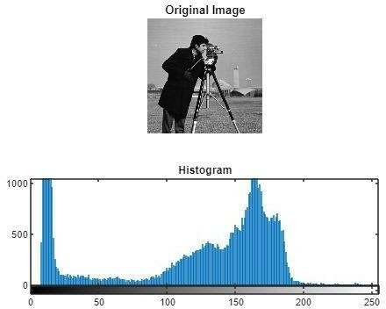

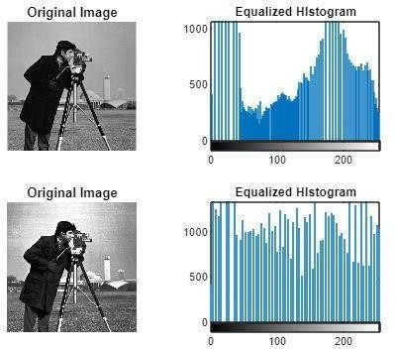

**% Expt. No. 9**

# % Aim: Implement Huffman coding algorithm for image compression

clc; close all; clear all;

p = input('Enter the probabilities'); Ps = sum(p);

m = fix(Ps); display(m); if(m == 1)

S = sort(p,'descend'); N = length(p); display(N);

symbols = input('Enter the sysmbols of length N'); display( symbols);

[dict, avglen] = huffmandict( symbols, S); display(dict);

temp = dict;

for i = 1:length(temp)

temp{i,2} = num2str(temp{i,2});

end display( temp) display(avglen);

sig = input('Enter the array of random source');

encode = huffmanenco(sig,dict); display(encode);

decode = huffmandeco(encode,dict); display(decode);

else end

N = length(p); Hx = 0;

for i =1:N;

Hx = Hx-(p(i)*(log2(p(i)))); end

disp('entropy') display(Hx);

Efficency = Hx/avglen; display(Efficency ); Percentage_Efficiency = 100*Efficency; display(Percentage_Efficiency );

# Output:

Enter the probabilities [0.4 0.3 0.3]

m = 1

N = 3

Enter the sysmbols of length N {'a' 'f' 'g'} symbols = 'a' 'f' 'g'

dict = **'a' [ 1] 'f' [1x2 double]**

**'g' [1x2 double]**

temp = 'a' '1'

'f' '0 1'

'g' '0 0'

avglen = 1.6000

Enter the array of random source{'a' 'f' 'g' 'f'}

encode =

1 0 1 0 0 0 1

decode =

'a' entropy

'f' 'g' 'f'

Hx = 1.5710

Efficency = 0.9818

Percentage_Efficiency = 98.1844